Suman Paudel (33)

Assignment III

# Lab 3:

**Prepare Lab Sheet of MYSQL Statements for following. Use the Company Database in Lab-1 and Lab-2.**

1. Select the names of employees and their dependents without using JOIN.

**SQL Script**:

**select**

*e*.***ename*** **as** *employee_name*,

*d*.***dname*** **as** *dependent_name*

**from**

***employee*** *e*,

***dependents*** *d*

**where**

*e*.***ssn*** = *d*.***ssn***

;

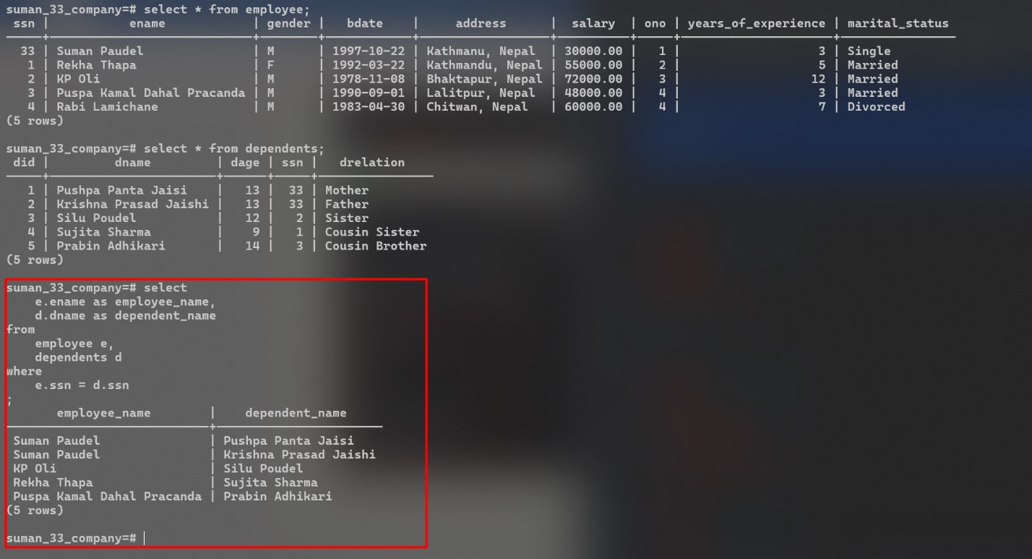**Output:**

1. Select the names of employees and their dependents without using INNER JOIN and order the result based on dependents name.

**SQL Script:**

**select**

*e*.***ename*** **as** *employee_name*,

*d*.***dname*** **as** *dependent_name*

**from**

***employee*** *e*,

***dependents*** *d*

**where**

*e*.***ssn*** = *d*.***ssn***

**order** **by**

*dependent_name*;

**Output:**

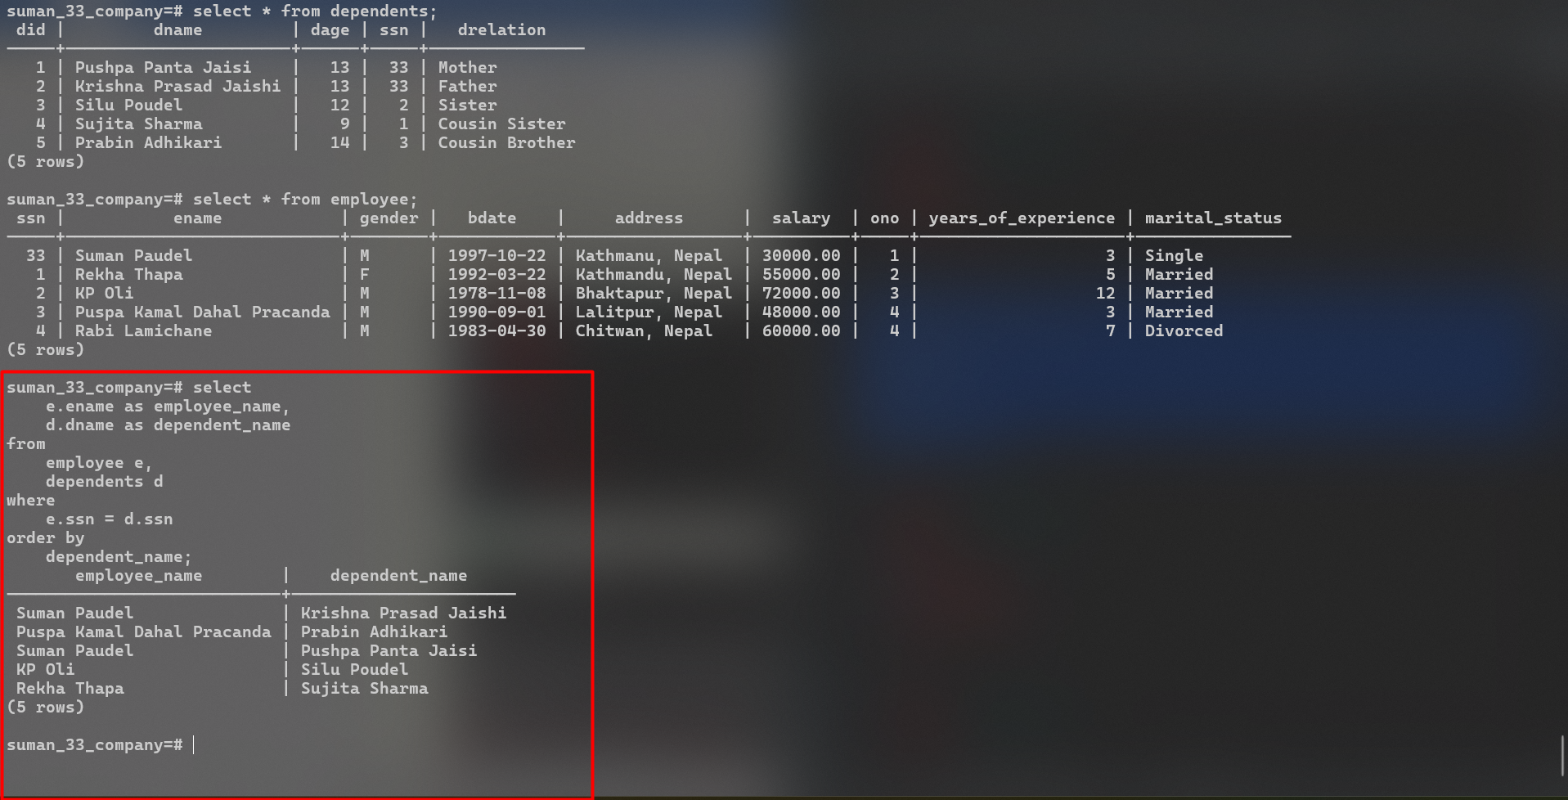

1. Use JOIN between Employee, Project and Works_on and retrieve the name of employees and the projects on which they work

**SQL Script:**

**select**

*e*.***ename*** **as** *employee_name*,

*p*.***pname*** **as** *project_name*

**from**

***employee*** *e*

**inner** **join** ***works_on*** *w* **on**

*w*.***essn*** = *e*.***ssn***

**inner** **join** ***project*** *p* **on**

*p*.***pnumber*** = *w*.***pno***;

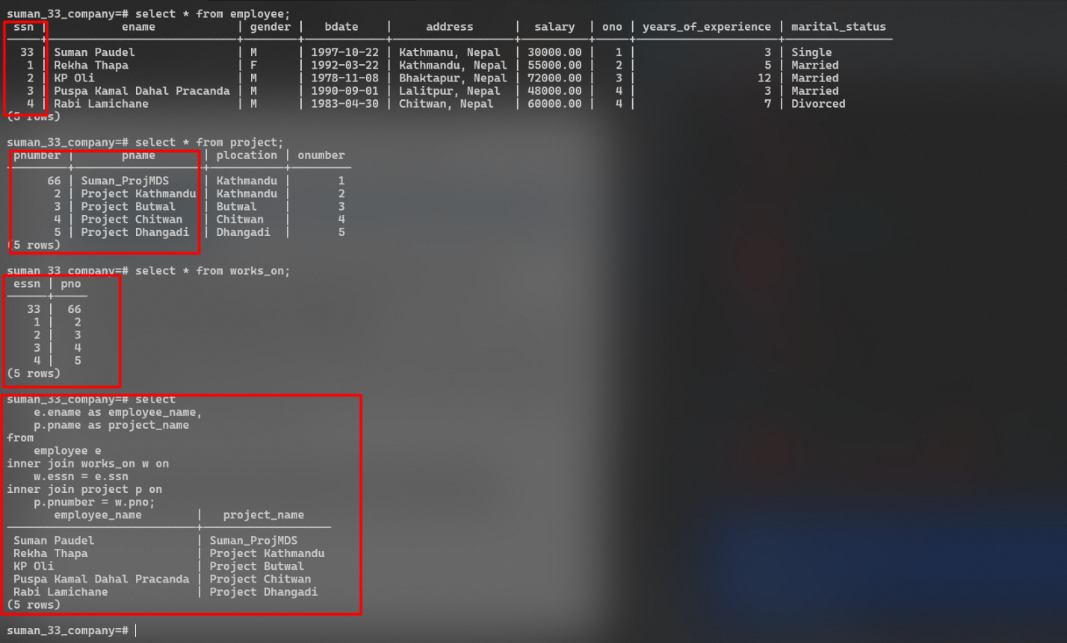**Output:**

1. Use Inner join between Employee and PF table with the join condition, Employee.SSN=PF.SSN and Employee.Salary>PF.Amount.

**SQL Script:**

**select**

*e*.***ename*** **as** *employee_name*,

*p*.***amount*** **as** *pf_amount*

**from**

***employee*** *e*

**inner** **join** ***pf*** *p* **on**

*e*.***ssn*** = *p*.***ssn***

**where**

*e*.***salary*** > *p*.***amount***;

**Output:**

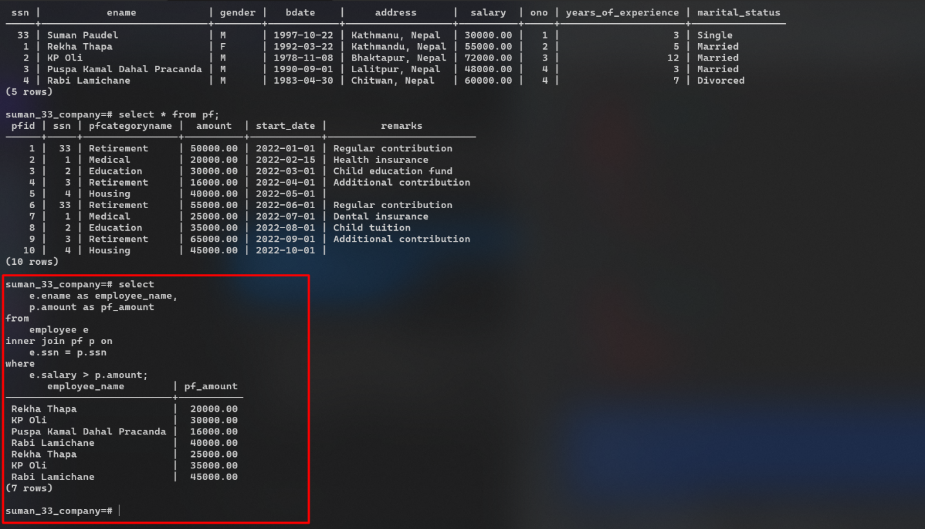

1. Write a query to show the results of Left and Right Join between Office and Project.

**SQL Script For Left Join:**

**select**

*o*.***oname***,

*p*.***pname*** **as** *project_name*

**from**

***office*** *o*

**left** **join** ***project*** *p* **on**

*o*.***onumber*** = *p*.***pnumber***;

**SQL Script For Left Join:**

**select**

*o*.***oname***,

*p*.***pname*** **as** *project_name*

**from**

***office*** *o*

**right** **join** ***project*** *p* **on**

*o*.***onumber*** = *p*.***pnumber***;

**Output for Both Left and Right Join:**

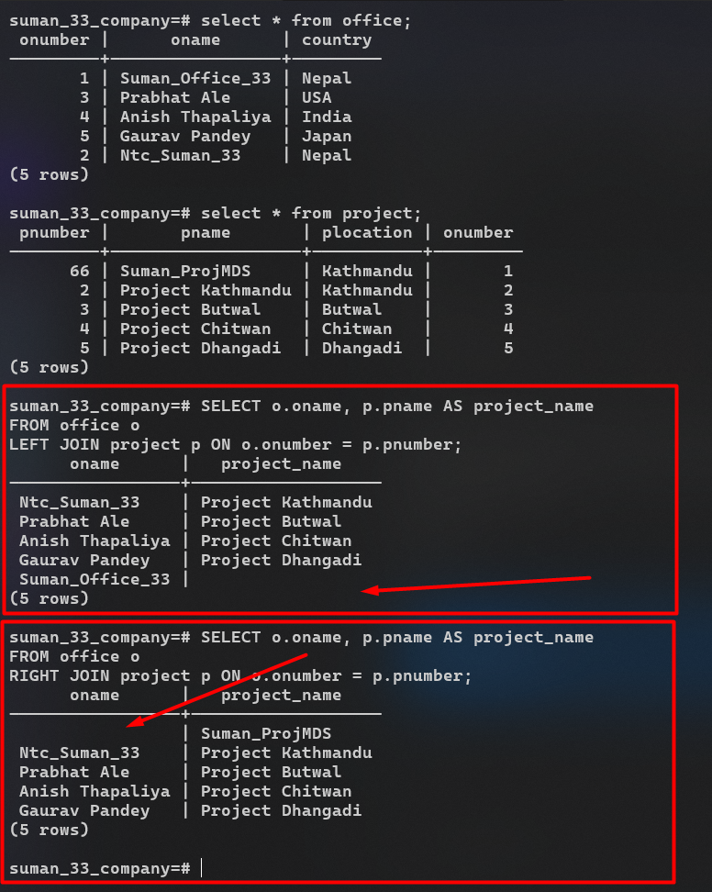

1. Write a query to show the results of Cross Join between Employee and PF tables.

**SQL Script:**

**select**

*e*.***ename*** **as** *employee_name*,

*p*.***amount*** **as** *pf_amount*

**from**

***employee*** *e*

**cross** **join** ***pf*** *p*;

**Output:**

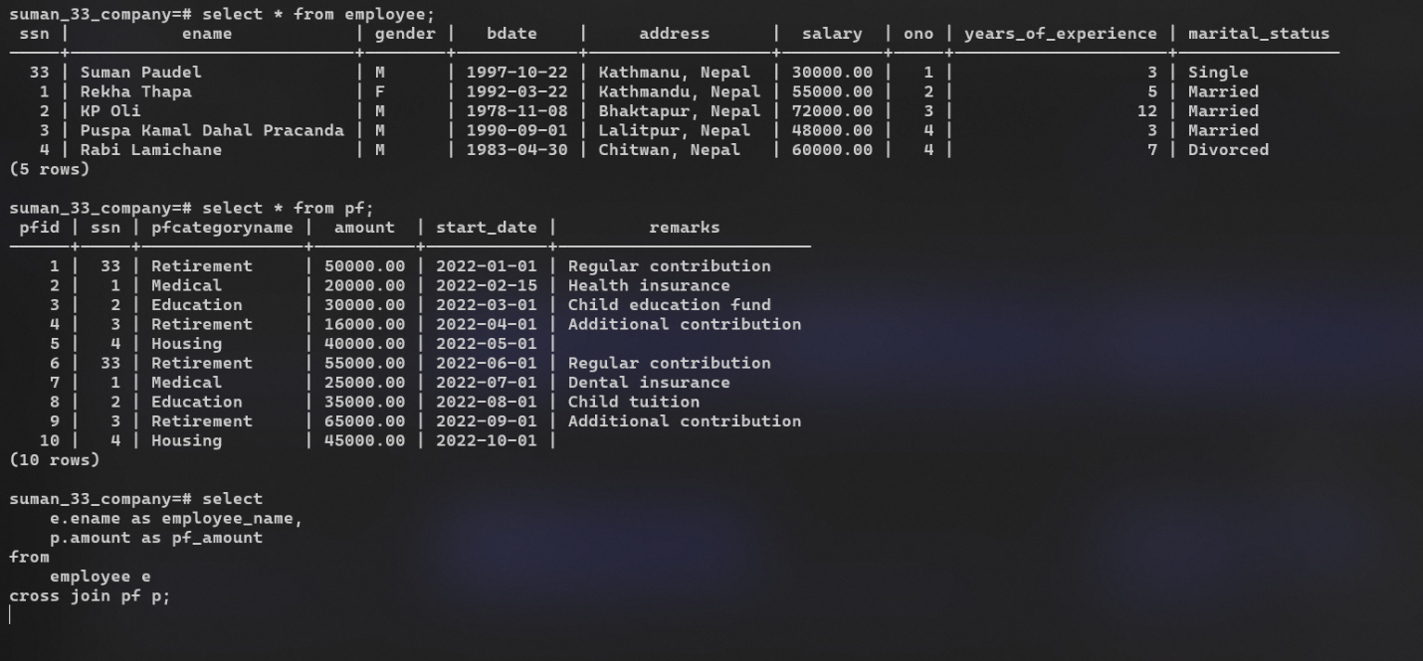

**Q6 Output Continued…:**

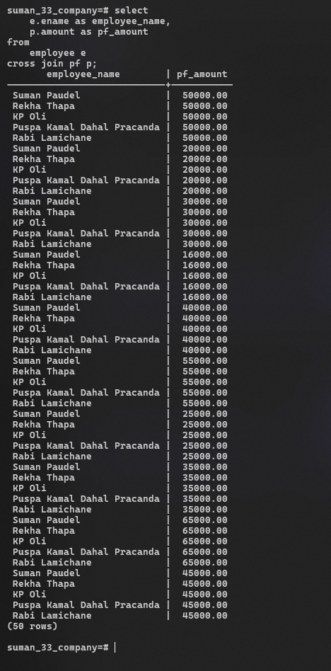

1. Show results of using natural join between Employee and PF.

**SQL Script:**

**select**

*e*.***ssn***, *e*.***ename***,

**from**

***employee*** *e*

**join** ***pf*** *p* **on**

*e*.***ssn*** = *p*.***ssn***;

**Output:**

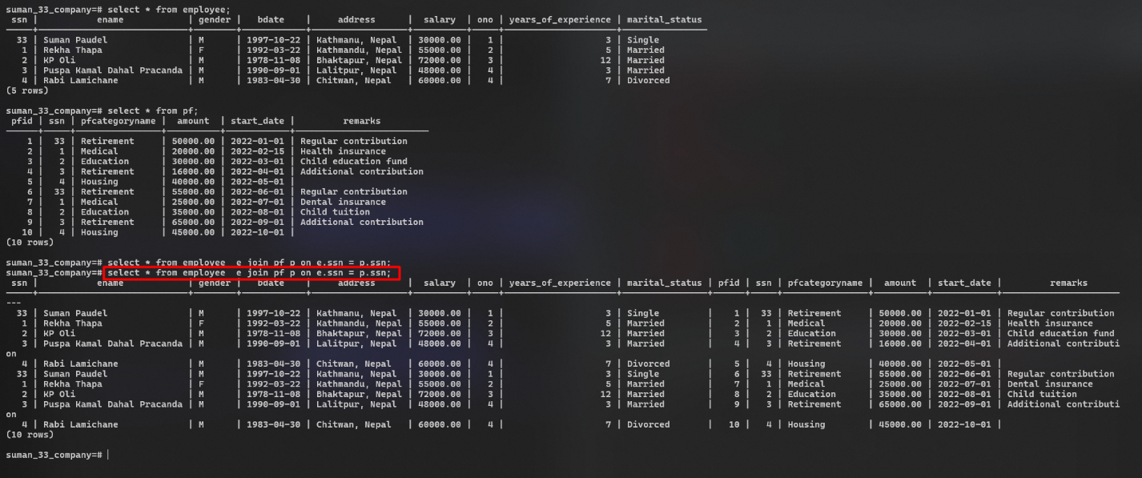

1. Find the number of employees and status in each status of “Married”, “Single”, “Divorced”. Use the COUNT function with the GROUP BY clause with status.

**SQL Script:**

**select**

**count**(*) **as** **number**,

***marital_status***

**from**

***employee***

**group** **by**

marital_status;

**Output:**

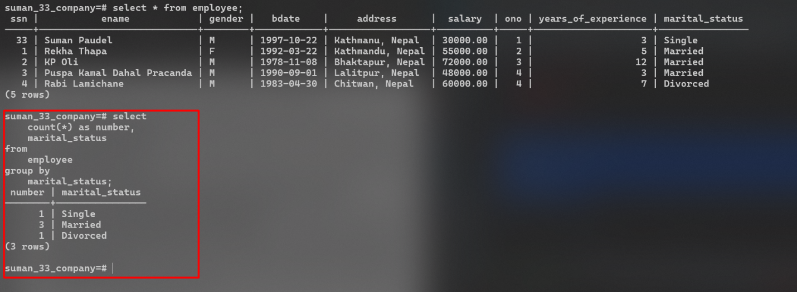

1. Find the number of employees and status in each status of “Married” OR “Single”. Use the COUNT function with the GROUP BY clause with status and Having clause with status = “Married” OR “Single”.

**SQL Script:**

**select**

**count**(*) **as** **number**,

***marital_status***

**from**

***employee***

**group** **by**

marital_status

**having**

***marital_status*** = **'Single'**

**or** ***marital_status*** = **'Married'**;

**Output:**

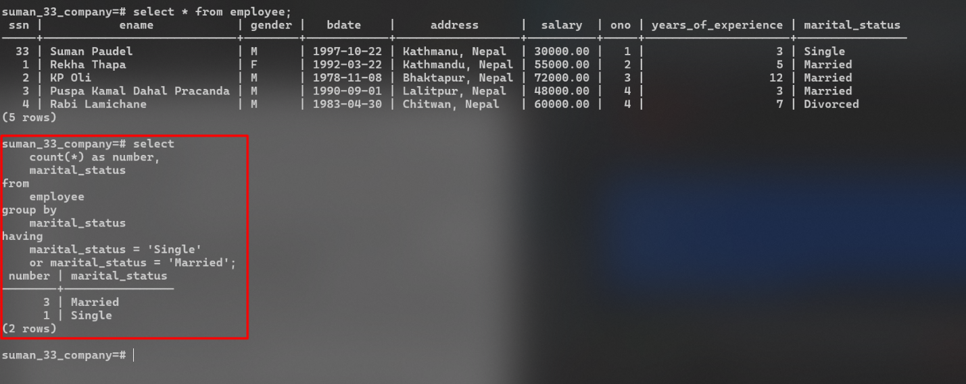

1. Using sub query, select the name and location of projects whose Onumber is in the Onumber of the offices located in country Nepal and India.

**SQL Script:**

**select**

*p*.***pname***,

*p*.***plocation***

**from**

***project*** *p*

**where**

*p*.***onumber*** **in** (

**select**

*o*.***onumber***

**from**

***office*** *o*

**where**

*o*.***country*** **in** (**'Nepal'**, **'India'**));

**Output:**

